Literature Review

Motorsports is where speed, precision, and cutting-edge technology come together. It is all about engineering, physics, and innovation. From aerodynamics and vehicle dynamics to power trains and tire technology and from design to techniques of driving a racing car. Some people thing why every major motorsport league cars flat and have a wide wheel base? It is because the wider the car, the faster it corners.

When a race car approaches a corner, without some forces applied, the car (and driver) would continue on a straight like (due to inertia). The force must produce a change in direction toward the center of the curve. The type of force that acts perpendicular to the car’s velocity is called centripetal force. It means center-seeking. It acts to change the direction of the car but not the speed.

Let’s cover the key aspects of vehicle dynamics and physical principles that govern how a car behaves on a racetrack:

# The Rubber hits the Road –

Tyres are the only point of contact between the car and the road, so understanding their behaviour is critical for optimizing traction, braking, and cornering. The viscoelastic nature of tyre rubber is why tyre performance is so difficult to manage. In racing, tires are optimized for specific track conditions. Slick tyres are used in dry conditions, maximizing surface contact and grip, while treaded tyres are designed for wet conditions to channel water and prevent hydroplaning. A tyre isn’t round when it’s supporting the weight of the car: The flat spot where the tyre touches the ground is called the **contact patch.**

* 1. – **How tyre rubber works**:

The reason why tyres exhibit such unpredictable behaviour is because they are made of rubber which is a viscoelastic material. We need to first understand elastic and viscous materials.

1. Elastic Material:

Elastic material deform linearly when a load is applied. Once this load is removed it returns back to its original shape. Think of it as a spring: when you push it, the spring compresses and when you let go, it expands back to its original length. The harder you push the spring, the more it compresses and the displacement is proportional to the applied force. Michelin, the tyre company has put out a lengthy pdf talking about tyre grip.

1. Viscous Material:

A viscous material deforms at a constant rate when load is applied and does not return back to its original shape once the load is removed. Think of it as a piston being pushed through oil. As you push the piston, the viscosity of the oil resists the piston, so the harder you push, the greater this resistance. When you let go, the resistance in the oil will push the piston back, but not on its original position. This is because the resistance in the oil has converted some of the energy you used to push the piston into heat, therefore there is an energy loss so the piston doesn’t return to its original position. The lag between the displacement behind the applied force and the piston to be out of phase is called hysteresis.

Rubber is what is used for making tyres but the behaviour of rubber is affected by three main things:

* Energy loss – dissipated as heat due to phase lag
* Hysteresis – when stress and deformation are out of phase
* Modulus – characterises the rigidity of the material. Soft materials have a low modulus, while hard materials have a high.

1. Influence of Temperature:

At low temperatures, the modulus of rubber is high so it becomes brittle and rigid. Whereas at high temperatures, the modulus of rubber is low making it flexible and elastic. For instance, before every race the drivers go out on the track to warm up their tyres so that at the start of the race they don’t slip out because the tyres weren’t warm enough and it was no flexible to handle tight turns. The picture below explains about the glassy state of tyres before warming up.

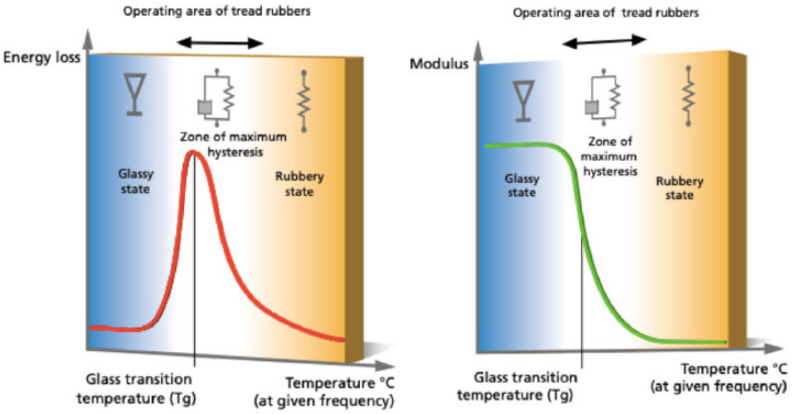

Figure 2 The Glassy nature of the tyre with respect to the temperature

* 1. – **How tyre grip is generated**

Grip is defined as the coefficient of friction between the surface of the tyre and the surface of the racetrack. The friction happening between the tyre and the road surface provides enough grip to perform various manoeuvres. But this thing called grip also depends on an array of factors like track quality, type of track, temperature and the tyre rubber. These factors ultimately affect the deformability and viscosity of the tyre rubber which along with the tyre’s hysteresis are key factors in the generation of grip.

A tyre generates grip from two types of stress mechanisms:

1. Indentation (also known as road roughness effect):

The rubber is distorted when it slips over the rough spots on the road. Because rubber is viscous, the deformation of a tread block, as it moves over the road surface, can be compared to flow. The block strikes the rough spot and distorts, but, because of hysteresis, does not immediately return to its initial height on the other side of the rough spot. This asymmetrical deformation of the rubber generates a reaction force which opposes slippage – in other words, it generates grip.

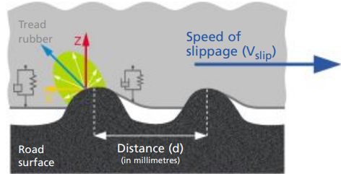

Figure 3 The asymmetrical deformation of the rubber block around the rough spot generates a force which opposes slippage.

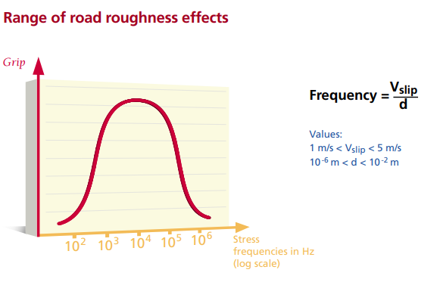

Figure 4

1. Molecular Adhesion :

Adhesion results from molecular interactions occurring at the rubber/ground interface (Van Der Waals’ force*). Bonds form, stretch and then break, to form another bond. The rubber’s molecular chains therefore follow a cycle of stretching and breaking which generates visco-elastic work (friction between molecular chains in a certain volume of material). This work multiplies the bonding energy by a factor which can vary from 100 to 1000 depending on the temperature and the speed of slippage of the rubber over the road surface.

Molecular adhesion is the reason behind why a tyre deposits rubber on a racetrack and on roads. The molecular bonds can either break away from the track or break away from the tyre, in which case rubber molecules are effectively torn off the tyre and remain on the track’s surface.

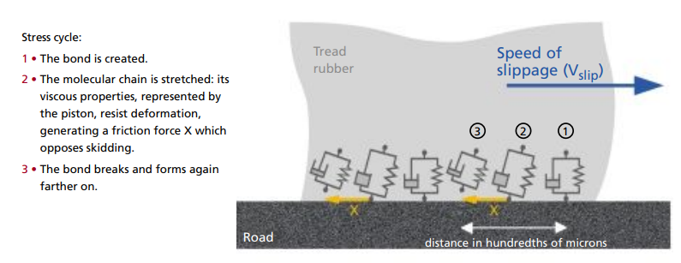

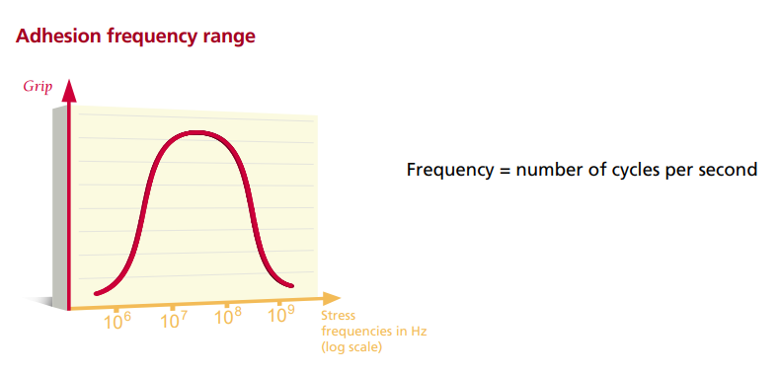

*Van Der Waals’ forces are weak intermolecular forces that are dependent on the distance between atoms or molecules. These forces arise from the interactions between uncharged atoms/molecules.

* 1. **How tyre grip affects tyre dynamics:**

Under acceleration and braking, additional slip is observed as a result of the deformation of the rubber elements in the tyre tread as they deflect to develop and sustain the friction force. As tread elements first enter the contact patch they cannot develop a friction force because of their compliance – they must bend to sustain a force.

1. Slip Angle:

It is defined as the angle (degrees) formed between the actual direction of travel of the wheel and the ‘pointing’ direction of the wheel (perpendicular to the axis of rotation). There is always an angle between the two when a lateral acceleration is experienced by a race car.



The gif above shows how the elements within the contact patch have been displaced in alignment with the direction of travel (also as the gif shows, the driver is counter-steering to avoid being spun out, this will be discussed later). These elements then return to the neutral condition towards the rear of the contact patch as the reactions forces reduces.

Whenever slip angle is introduced, the contact patch deforms as lateral forces act on the tyre. This deformation generates strain (elongation) within the molecular structure of the tyre rubber. Also, the elasticity of the tyre compound resists this strain which generates a force normal to the axis of rotation. This stretch-relaxation cycle that the tyre repeats every revolution also general internal friction and therefore heat within the tyre, increasing the grip.

Larger slip angles mean more sliding, There has to be *some* sliding to get the maximum turning force, but too much sliding decreases the turning force.

(Add a picture of contact patch and slip areas from the *Physics of NASCAR*)

1. Slip Ratio:

The concept of slip angle is applied in describing lateral force production only. In the longitudinal sense, this is known as the slip ratio. The slip ratio is similar to slip angle but instead of being measured in angular displacement – between two and four degrees, it relates to the amount of slip a tyre experiences relative to a sliding condition. It’s like *The Price is Right* gameshow: Get as close as possible to the ideal slip angle without going over.

For example, a slip ratio of 0 is a free rolling tyre and a ratio of 1 is a tyre that has lost traction (driving on ice using slick tyres).

1. Friction Circle:

The last fundamental of tyre dynamics that is necessary to understand is that of the friction circle or g-g diagram. The friction circle graphically illustrates the limits of a tyre generating both longitudinal and lateral

acceleration simultaneously, and allows understanding of how the vehicle is being driven relative to this.

Here’s a good example of g-g diagram. The small blue dot shows that the car is in the process of braking and taking a left turn hence both the driver and the tyre is experience g-forces along the line.

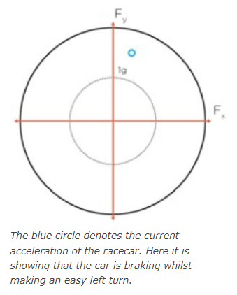

The g-g diagram resembles an ellipse rather than a perfect circle, a driver cannot expect the level of lateral acceleration generated in pure cornering whilst demanding acceleration/braking and vice versa.

Techniques such as ‘trail braking’ emerged exactly to maximise the frictional effort of the tyre and ensure the race car is at the ‘edge’ of the friction circle as much as possible.

The graph below shows that the tyres of a V8 supercar experienced acceleration, braking and most of the time the car took more right turns than left turns (more red dots on the left side than right side).

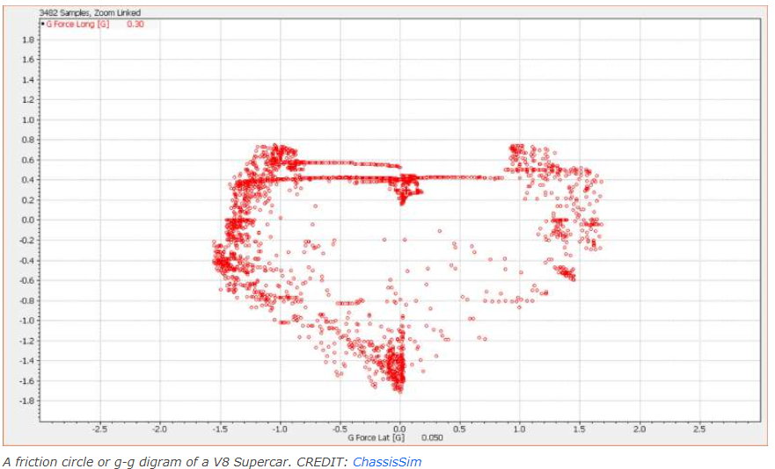

1. Extrinsic Factors Affecting Adhesion:

It’s not only intrinsic factors inherent to a specific tyre such as rubber compound and construction that affect levels of adhesion. There are also a number of extrinsic factors that influence friction between the tyres and the road.

1. Compound Temperature:

The temperature affects the adhesion of the tyre compound by increasing both the compliance and penetration of peaks and valleys in the road into the contact patch. This also increases the rate of chemical reaction between the tyre rubber and asphalt, but only up to a point, after which the tyre will ‘go off’ and grip levels reduce.

Heat dissipation is the reason racing tyres don’t have tread patterns like passenger-car tyres. The flat surface of a slick racing tyres helps dissipate heat better. The thinner tread on a racing tyre – about one-eighths of an inch compared to three-eighths of an inch on a new passenger-car tyre – also improves heat dissipation.

1. Inflation Pressure:

Due of the flexibility of tyre rubber, inflation pressure introduces deformation at the contact surface, ranging from a concave profile (low pressure) to a convex profile (high pressure). This affects the surface area of the contact patch. Somewhere in between the two is a flat profile which provides maximum contact area and the optimal adhesion.

A typical tyre pressure (for a consumer vehicle) of 30 pounds per square inch (psi) means that one square inch of the contact patch. Sometimes if teams are struggling for tyre temperature, they boost the tyre pressure which results in convex profile and a very narrow contact patch. This contact patch heats up quicker, which then radiates throughout the rest of the tyre, increasing its overall temperature.

In NASCAR, the tyre pressure on the left side of tyres is way less than the right. In Atlanta Motorspeedway, the recommended tyre pressures are 22 psi (left front), 20psi (left rear), 48psi (right front) and 45psi (right rear). The right-side tyres carry much more of the weight during cornering, which is why they are inflated to higher pressures.

1. Track condition:

Variables such as track surface roughness, wet track, dusty track all influence the level of adhesion.

The crew members of the team adjusts the tyre pressure to suit the track conditions. For instance, hotter weather conditions = slicker track, less grip and more sketchy, harder to drive & cold weather = grippy track, more grip and easier to drive.

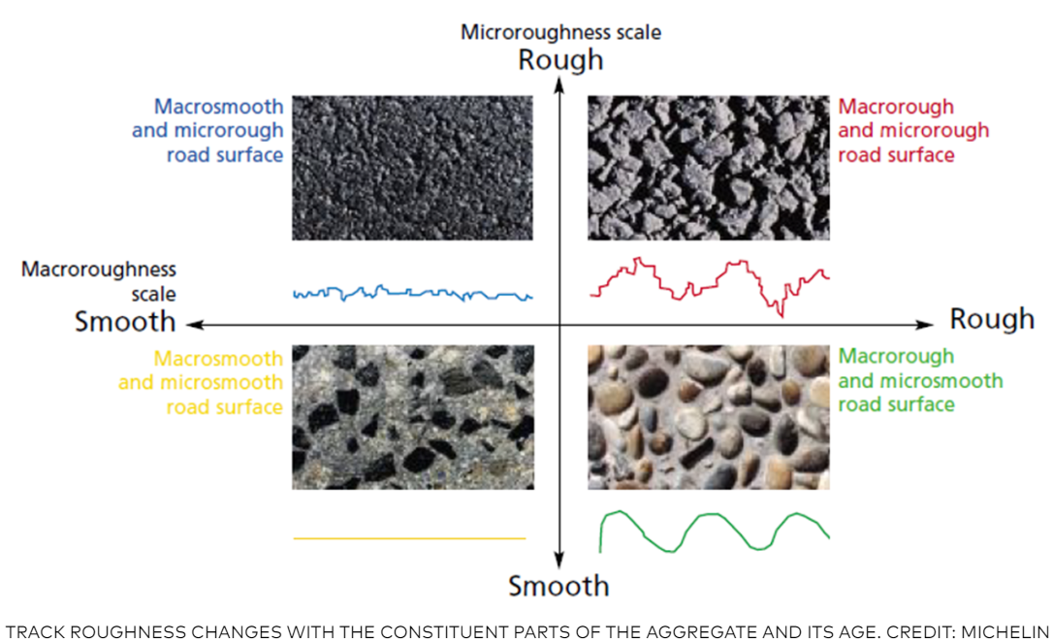

# Car-natomy in Motion –

Vehicle dynamics deals with how the car responses to driver inputs (steering, throttle, brakes) and external forces (gravity, friction, inertia). Inertia refers to the car’s resistance to changes in its rotational motion. Cars with their mass concentrated near the center (low moment of inertia) are easier to turn and handle better.

* 1. – Newton’s Laws of Motion:

Most people remember Newton’s law from school. These are the fundamental laws that apply to all large things in the universe.

1. Newton’s First law – A car in straight-line motion at a constant speed will keep such motion until acted on by an external force (like friction, drag, or turning forces). The only reason a car in neutral will not coast forever is friction, an external force, gradually slows the car down. Friction comes from the tires on the ground and the air flowing over the car. The tendency of a car to keep moving the way it is moving is inertia of the car, and this tendency is concentrated at the centre of gravity point.
2. Newton’s Second law – When a force is applied to a car, the change in motion is proportional to the force divided by the mass of the car. This law is expressed by the famous equation:

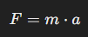

Where

* *F =* Force
* *m =* Mass
* *a =* Acceleration

A larger force causes quicker changes in motion, and a heavier car reacts more slowly to forces. Newton’s second law explains why quick cars are powerful and lightweight.

1. Newton’s Third Law – Every force on a car by another object, such as the ground, is matched by an equal and opposite force on the object by the car. When the driver apply the brakes, he cause the tires to push forward against the ground, and the ground pushes back. As long as the tires stay on the car, the ground pushing on them slows the car down.
   1. – Weight Transfer:

Most racing cars are rear-wheel drive. As the car accelerates, more of the weight is supported on the rear wheels. This process is called ‘weight transfer’.

* During acceleration, weight shifts to the rear wheels, increasing rear traction but reducing front traction.
* During braking, weight shifts forward, increasing front-wheel traction and reducing rear-wheel grip.
* During cornering, lateral weight transfer happens, with more load on the outer tires. This affects how much grip the car has while turning.

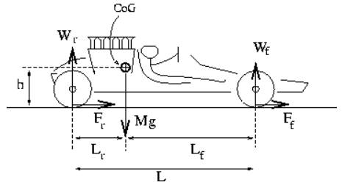

Figure 1 The forces acting on the front and rear wheels of an accelerating car

Now is this is where the CG or CoG or Center of Gravity point is used as reference (from the Newton’s First Law).

* Wr and Wf is the weight on the rear and front tires.
* Fr and Ff is the force on the rear and front tires.
* Lr and Lf is the corresponding length between the mass of the car.
* Mg is the mass of the car.
* h is the height between the road and the engine (CoG).

For a racing car, the CoG is located between the wheels and as close to the ground as possible.

When the car is at rest (Ff = Fr = 0), the up and down forces must balance:

Mg = Wf + Wr

And the torque on the car’s body due to the reaction forces must also be zero (since the reaction forces do not act through the center of gravity.)

Lf x Wf = Lr x Wr (at rest)

Figure 1 shows the forces acting on the car as it accelerates. The sketch looks more like the 50s or 60s F1 cars to get a gist of how these forces work.

Lf x Wf +h x Fr = Lr x Wr

Wf = Lr x Mg – h x Fr / L

Wr = Lf x Mg – g x Fr / L

* A lower CG improves handling and reduces body roll.
* A higher CG can lead to more body roll and make the car more likely to tip during hard cornering.
  1. – Suspension configuration:

The suspension is responsible for presenting the wheel to the road surface in the desired orientation – the intricacies of which are highly important in the sense of tyre dynamics.

The configuration most widely seen in race cars is the Double Wishbone/A-Arm system. With short and ‘tidy’ load paths; members are loaded exclusively in tension and compression offering package and weight (inertia) advantages over other configurations, but it also offers the greatest control over the kinematic behaviour of the wheel in response to vertical displacements. The front and back suspensions are configured differently because the rear wheels drive the car while the front wheel steer.

Formula 1 and Endurance race cars uses Double Wishbone system & NASCAR uses Control arms or A-Arm system.

First let’s discuss about the control arms suspension:

* They are also called ‘A-Arms’ because they’re shaped like the letter A. The pointy tips of the A-arms are attached to the steering knuckles with ball joints that allow them to move left and right, up and down. The two legs of the control arms attach to the frame with hinges. The springs rest on the lower control arms and are held in place on top by a horizontal plate attached to the frame with a threaded bolt that can be tightened or loosened to change the spring’s resting length.
* The rear suspension uses trailing arms which are long pieces of metal I-beam that run from about the mid-point of the car, where they are connected to the frame with hinges, to the real axles. The rear springs rest in pockets on top of the truck arm, just ahead of the axle, and, as in the front suspension, are held in place by adjustable plates attached to the frame.
* When racing, there is some kind of tension or stress caused by constant push and pull movement of suspension. It’s called Torsion. Best way to understand is to hold a person’s arm straight out from the body and ask someone wot grab the wrist and gently twist. That stress cause in the wrist is Torsion.

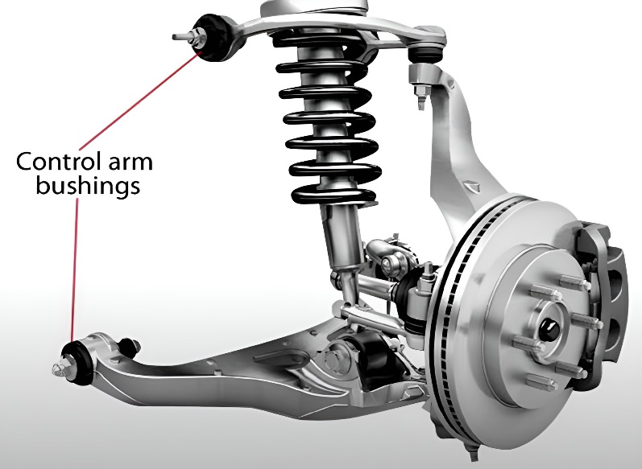

Let’s discuss the double wishbone suspension system which is highly used in supercars, F1 and hyper cars in endurance racing.

* A double wishbone setup is made up of two wishbone-shaped arms with one on the top and another at the bottom, with the damper attached to the latter.
* Its geometry is vastly different than other suspension setups with the shock absorbers protruding from the top. With this design, its more compressed, the more negative camber, the better in cornering hard and avoiding the car to roll while maintaining a better tyre contact patch with the road.
* Because of its complex design, the double wishbone allows for greater control over camber, caster and roll centre (we’ll discuss this after the suspension). There’s also much more freedom with the placement of the dampers, leading to the trick inboard setups in many racing cars and on some road legal supercars.

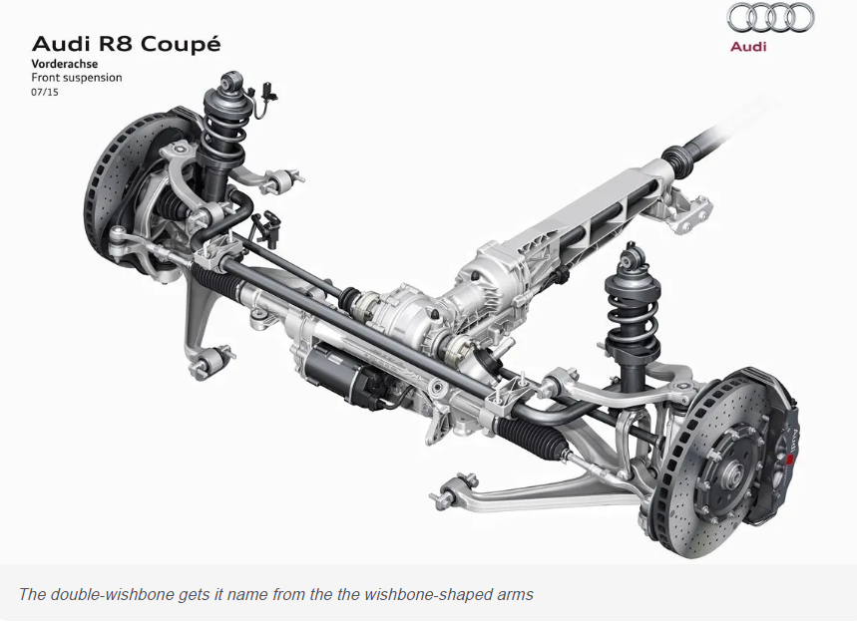

The axle roll centre is also essential to consider when designing suspension geometry. The roll centre defines the size of the moment arm between the Centre of Mass, and the point lateral force applies to the sprung mass. This is important for two reasons:

1. The size of the moment arm dictates the magnitude of the rolling moment on the sprung mass, affecting roll stiffness required from the springs and ARBs.
2. The vertical displacement of the roll centre location from the centre of the tyre contact patch force directly affects the magnitude of jacking force.

**The height of the wishbone instantaneous centres defines the vertical location of the roll centre. This means that wishbone geometry is crucial in determining roll centre behaviour**.

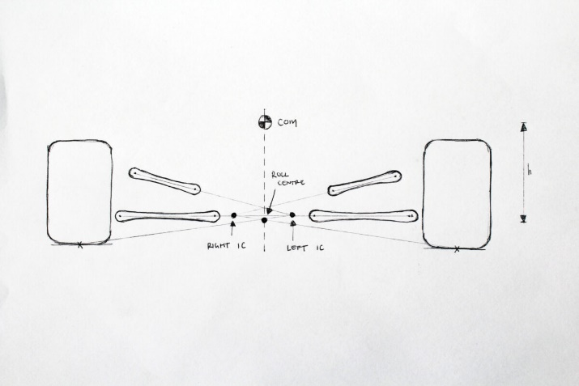

* 1. – Geometrical concerns

Directly influencing driving characteristics, there are two important degrees of freedom at the wheel available to the dynamicist: camber and toe. The definitions of toe and camber are assumed widely by many racing fans, however there is merit in understanding what exactly they are doing at the contact patch. All wheel geometry manipulations are ultimately either maximising the size of the contact patch present on the track surface (camber), or moving the tyre towards its peak slip angle during the cornering (toe).

There is no one-size-fits-all solution to wheel geometry and the optimal set-up is unique to each car and even further, unique to each application.

Let’s take a look at Camber & Toe setups

* Camber: Camber is a vertical inclination of the tyre. Zero camber means that the tyres are straight, perpendicular to the road and parallel to each other. With positive camber, the top of the tyres points outwards of the car. With negative camber, the top of the tyres points inwards.
* Toe: Toe is the angle the tyres are rotated around their vertical axis, looking at them from along the car. You have no toe if the tyres are parallel to each other, along the direction of the car. You have toe-in when the tyres point in towards each other, and toe-out when they point away from each other.

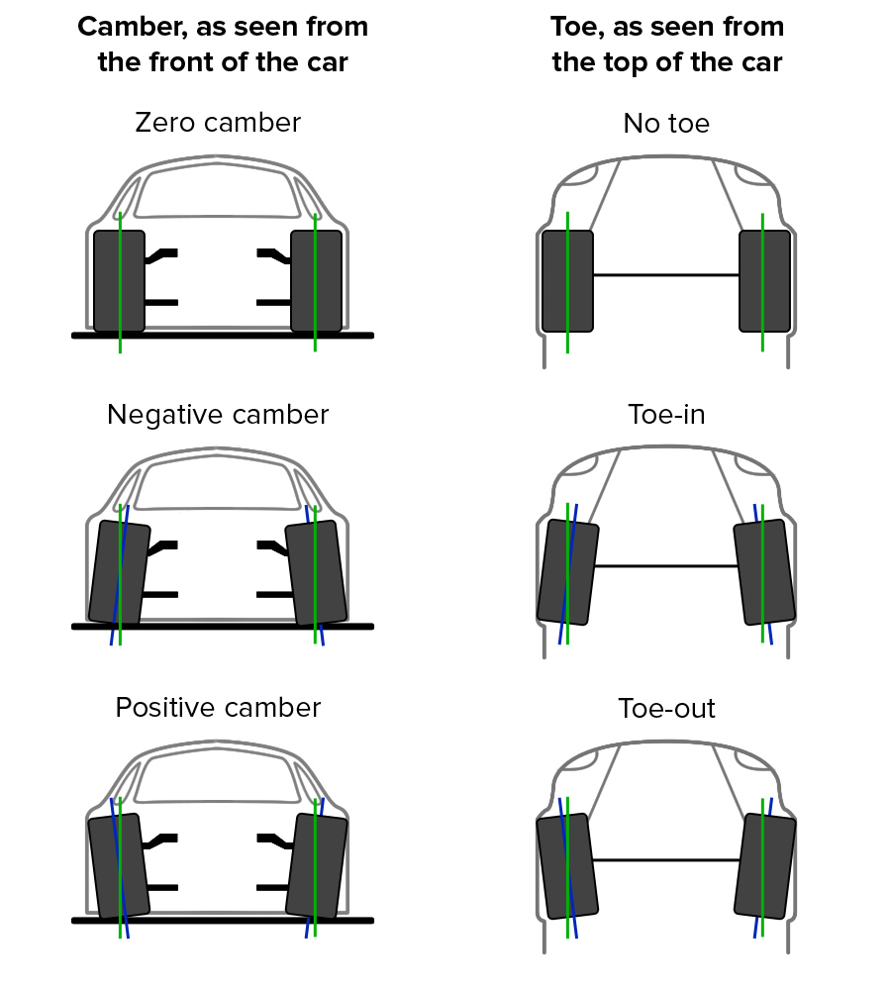

As the driver goes through a corner, the cornering force causes the car to roll and the tyre to deform, as it twists between the car which wants to go one direction, and the track that’s going the other direction. This is called lateral tyre deflection.

* With zero camber, the force on the tyres are equally distributed along the contact patch when you’re standing still or driving in a straight line. This increases the available grip under straight line braking and acceleration. Cornering with zero camber causes one side of the tire to unload, while the other side of the tyres takes more load. This causes unequal load distribution and lowers the overall available grip on the tyre when you need it the most: ***while cornering.***
* With negative camber, the force distribution along the contact patch is somewhat unequal while driving in a straight line. However, when cornering forces and carcass deflection come into play, they can negate the effect of negative camber, equalising load distribution along the contact patch. This maximises the available grip on the outside tyres, exactly the moment when the car is limited by its available grip. 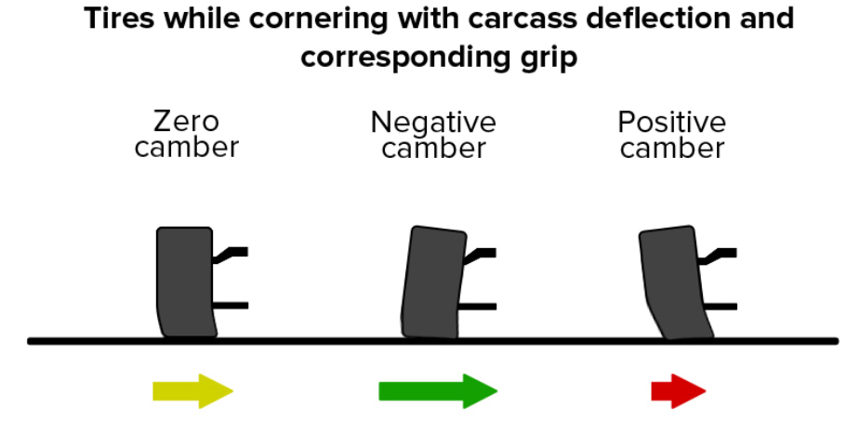
* Effects of toe-in and toe-out has more than one effect. If a person rolls a free tyre at an angle, it would want to follow an elliptical trajectory instead of a straight line. In other words: an angled tyre wants to turn. The force that causes this effect is called camber thrust. This results in a bit more friction, heat and wear, which can be offset by a toe-out adjustment. He can also use a toe-out adjustments to get the slip angles of the front tyres in a more optimal spot.

Mercedes came up with the cheat code during the F1 2020 season in their new W11 cars. The W11 has dual-axis steering wheel which helped them a lot while cornering:

1. On the straight -> Toe in – Pull the steering wheel

Increase front toe in to straighten the wheels and reduce drag down the straight.

1. Under braking -> Toe out – Push the steering wheel

Increase front toe out which reduces instability and scrubs the tyres: generating tyre temperature.

1. Corner exit -> Toe in – Pull the steering wheel

Increase front toe in to revert to base setup, which will still be a small amount of toe out.

By dynamically changing the front toe, this system could allow Mercedes to run more toe out in the corners, to increase tyre temperature, without suffering the drag penalties on the straights. However, FIA soon banned this system the in the beginning of 2021 season.

* 1. – Steering Geometry

Steering geometry is one of the many tools at a race car designer’s disposal to ensure the car extracts maximum performance from all four tyres.

Consider a low-sped cornering manoeuvre, where all tyres are in pure rolling condition, and there is no vehicle sliding present. As the vehicle travels along a curved path, all four tyres follow unique trajectories around a shared turn centre and if the driver takes, let’s say, a right turn; the left tyre will have more radius than the right tyre.

The different curvature radii mean that to avoid sliding, the steering geometry must steer the inside front tyre at a larger angle than the outside front. Ackermann Steering refers to the geometric configuration that allows both front wheels to be steered at the appropriate angle to avoid tyre sliding.

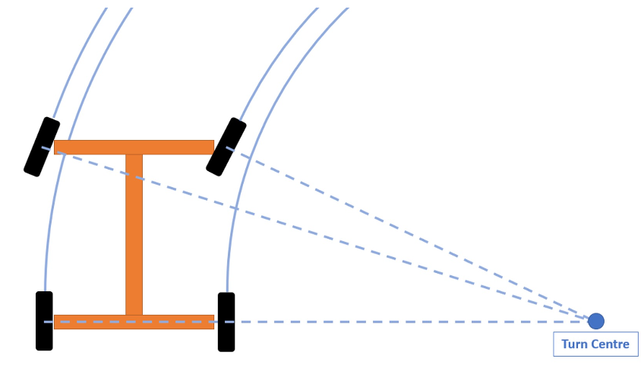

There is a complicated formula to solve for the Ackermann geometry, for a given turn radius R, wheelbase L, and track width T, engineers calculate the required front steering angles (f,in) and (f,out) with the following expressions:

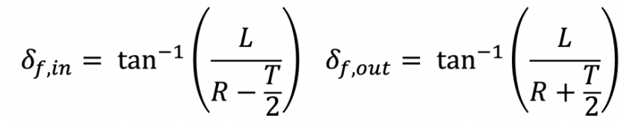

# The Airbenders –

When the car is in motion, an aerodynamic drag will develop that will resist the motion of the car. Drag force is proportional to the square of the velocity and the formula to calculate the force is as follow:

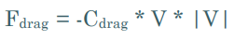

Aerodynamics start to have a more noticeable affect on a vehicle at around 50 mph. Downforce and drag values go up roughly with the square of the increase in speed and the power required to overcome the drag forces goes up at a slightly steeper rate.

The motion of air is complicated because the atoms or molecules in fluids – and air is *fluids* – are only loosely connected to each other. Describe the path of a thrown ball. The atoms in the baseball maintain the same positions relative to one another, so the ball moves through the air as a single unit. Now describe what happens when a person throws a slime. It is very difficult to describe because slime doesn’t have a fixed shape, it spreads out and even comes apart when thrown.

To help with better understanding of aerodynamics, lets look at the aerodynamic forces acting on a race car:

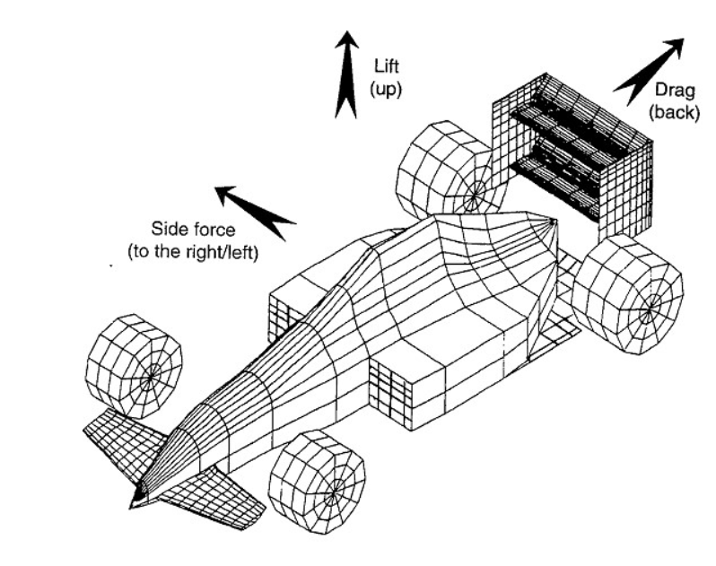

1. Drag – the resultant of aerodynamic forces that acts in the longitudinal axis of the car, opposing its movement. This is a cruel element of aerodynamics study, and it is of primary concern in road cars aerodynamics design. It must be overcome by the tractive force generated by the engine.
2. Lift – the resultant of aerodynamic forces that acts upward. Lift reduces the vertical forces of the car, and its reduction is of primary concern in racing car aerodynamics study. The opposite of lift is downforce, which is the resultant of aerodynamic forces that pushes the car against the ground.
3. Side Force – the resultant of aerodynamic forces that pushes the car sideways. This force is generated by lateral winds acting upon the vehicle. It is important for stability studies on road cars, but since lateral wind components are relatively small in racing vehicles, its important is reduced in motorsport environment.

Most of the motorsport teams have two tools at their disposal to test their cars: wind tunnels and computers. Computer are relatively recent, but wind tunnels have been used to study aerodynamics since 1871. The Wright brothers used a scale-model wind tunnel in 1901 to help design their first planes.

Wind tunnels have advanced quite a bit since then. Wind speeds range from just a few miles per hour to more than 20,000 mph in wind tunnels that are used to study airflow around ballistic missiles and spacecraft.

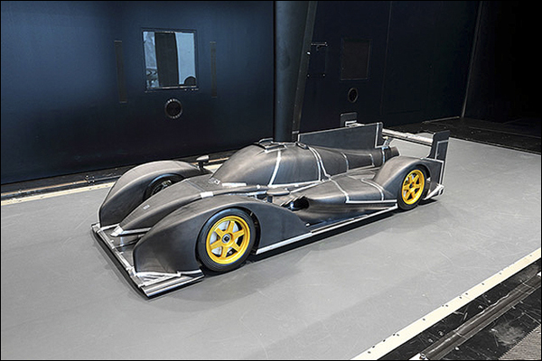



At first glance, a wind tunnel is just a big room with a very powerful fan. A closer look reveals much more. A bank of twenty-two individually speed-controlled, 100 horsepower electric fans stands about eighteen feet high and consumes 1.6 megawatts of electrical power - equivalent to 16,000 100-watt lightbulbs. Creating a hurricane-force winds indoors isn’t cheap.

A wind tunnel can let a team see – literally – how air moves over a car. The array of fans produces a smooth flow that acts like sheets of air stacked on top of each other.

As airflow separates from the surface of the vehicle, drag will go up at an increased rate beyond its normal drag curve, and lift will go down beyond its normal curve. The drivetrain shapes, tyre friction, tyre pressure, tyre heat, racetrack surface irregularities, toe angles, front camber angle, rear alignment, rear toe, and rear camber all affect the aerodynamic efficiency for a race car and with that the horsepower needed to overcome drag. It’s easier to get a five-horsepower gain in drag reduction than it is to squeeze 5 more horsepower out of the engine.

**Race cars in general have a peculiar shape that distinguishes it from any road car on the planet.**

Here’s a better example, look at two of the Aston Martin Vantages and find the difference:

 

The car on the left is a road-legal version and the right one is a pure motorsport focused version. Look how wide the right car is than the car on the left with additional body works like spoiler in the back, diffuser in the front and back bumper and side skirts. These tiny body work makes a lot of difference in racing because they end goal is to move swiftly through the air without using that much horsepower.

Different types of cars have different shape to pierce through the air in the fastest way possible. Like:

1. Formula 1

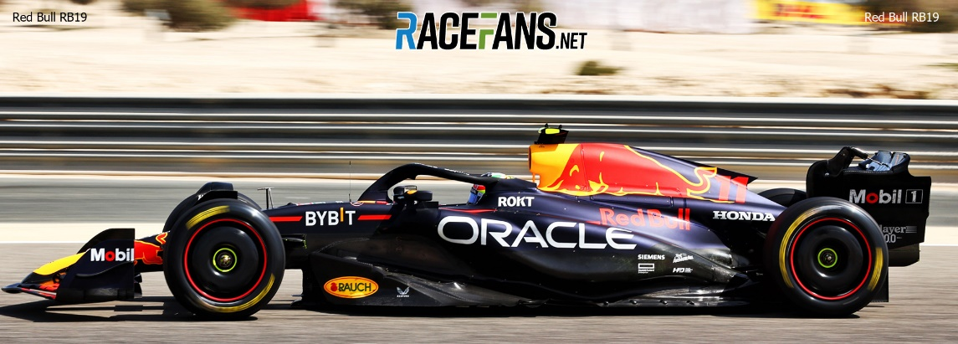

1. NASCAR

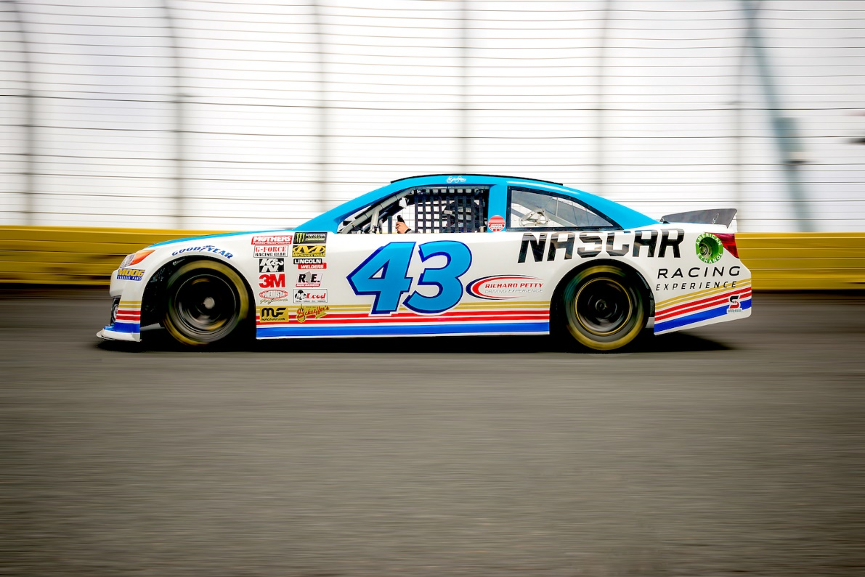

1. LeMans Hypercar

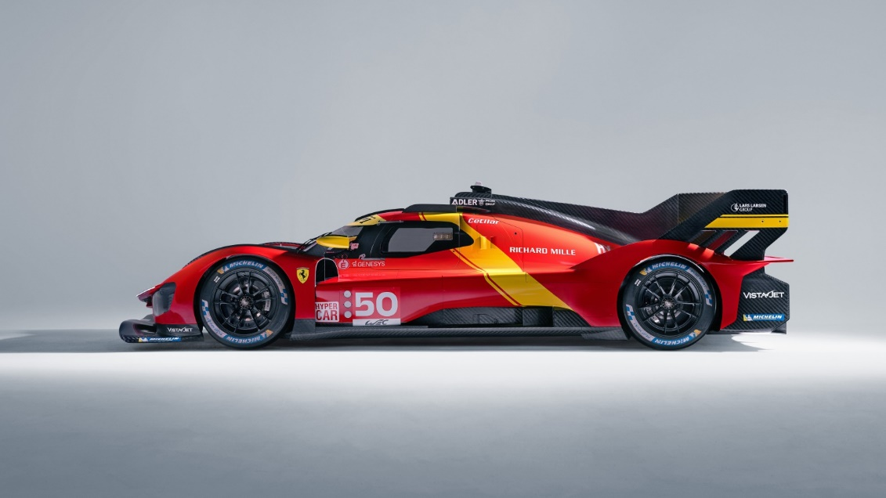

1. BTCC (British Touring Car Championship) Car

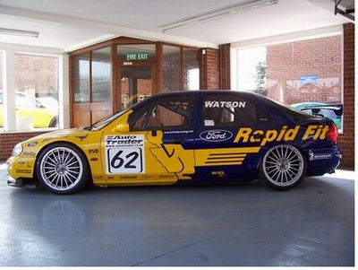

1. WRC (World Rally Championship)

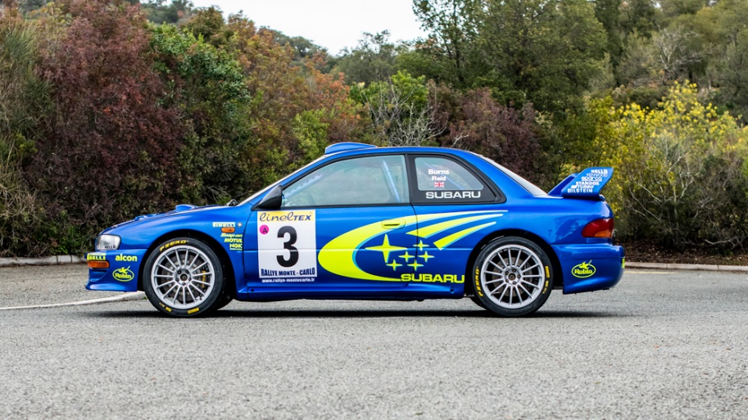

There was major design flaw in Mercedes CLR GTR, lack of total downforce and some really bad luck during the 1999 Petit Le Mans. Till this date the Mercedes CLR is considered a hypercar with poor design choices, inadequate downforce, a pitch-sensitive aerodynamic setup and bad luck on the high speed Mulsanne Straight.

This is how it went down:

* The CLR had a long front and rear overhand (with rear at 1140 mm) combined with a short wheelbase (2670 mm). This made the car highly sensitive to changes in pitch, causing the aerodynamic platform to destabilize easily.
* At high speeds, small changes in ride height or altitude could lead to significant aerodynamic imbalances.
* A small front diffuser and a body shape that inherently generated some lift.
* The biggest mistake of all time, a soft rear springs which reduced the rear’s ability to stabilize the car at high speeds.
* The result:



This happened twice, **TWICE**.

# Torque-tastic Power Play –

The engine is the main powerhouse of anything, whether it is a plane, a bus, a bike or even a tank, heck even for game development companies are using their own in-house engines to make a video game.

In racing, engines are tuned for high power and responsiveness. For example, naturally aspirated engines often feature high-revving characteristics, while turbocharged engines prioritize torque and power. And the racing teams use dynamometer – or dyno in short – to evaluate their engines. It is like a square room about twelve feet on a side and a four-by-three-foot window with bulletproof glass to let the engineers know what is happening.

The engines being assessed looks like an intensive-care patient, with hoses and wires everywhere. A piece of corrugated tubing, like the kind found in dryer vents, but larger, runs to the engine’s air intake. Another piece of tubing carries off exhaust. Bundles of cables and wires run from inside the dynamometer room to computers outside.

A dyno does not measure power directly. It measures torque. Torque is a twisting ability, like using a spanner for turning bolts or crankshafts. The torque is the force apply times the perpendicular distance between where the force is being applied and the center of rotation. If a person is having trouble loosening a lug nut, just use a longer wrench. Torque determines how fast the car can accelerate, and the amount of torque is determined by the force with which pistons rotate the crankshaft (engine speed). Engine speed is how many revolutions per minute (rpm) the crankshaft makes, and the engine produces different amounts of torque at different engine speeds.

The diagram below shows the graph of how much torque and power is being generated with respect to RPMs.

There’s a **point**, 7000 RPM, where everything **fades**. The **machine** becomes **weightless**, just **disappears**. All that’s left is a **body** moving through **space** and **time**.7000 RPM. That’s where you **meet** it. It asks you a question. The only **question** that **matters**. WHO ARE YOU?

*-Carroll Shelby, the man who sell race cars*

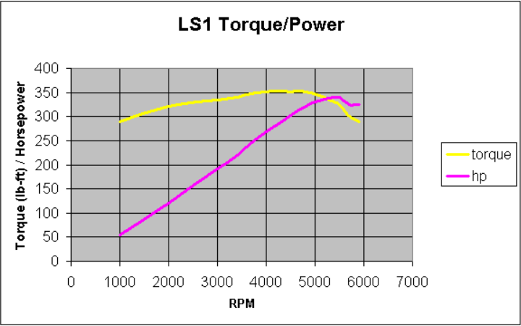

The engine’s horsepower is calculated by multiplying the torque (in foot-pounds) by the rotational speed of the engine (in rpm) and dividing by 5252. The unit of horsepower was introduced by James Watt, the inventor of steam engines, but now this unit is being used as a marketing tool than a true measure of a horse’s power output.

Now, the torque from the engine is converted via the gear and differential before it’s applied to the rear wheels. The gearing multiplies the torque from the engine by a factor depending on the gear ratios. Unfortunately, quite some energy is lost in the process. As much as 30% of the energy could be lost in the form of heat. This gives a so-called transmission efficiency of 70%. The torque on the rear axle can be converted to a force of the wheel on the road surface by dividing by the wheel radius.

There are many engine configurations which comes with their set of speciality. Front engine, mid-engine and rear engine. There is a book called Tune to Win, written by Carroll Smith, stating that the best position to put an engine in a car is rear-mid. Because of equal weight distribution, even F1 and companies like McLaren, Lamborghini, Ferrari, and Lancia (with their rally Stratos) follows the same strategy when it comes to making a well-balanced, high-performance vehicle.

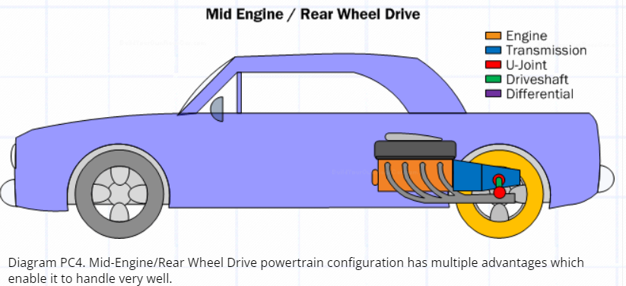

There are cars with turbocharged or supercharged engines. But what do they mean by that? Both are forms of forced induction engines. They use mechanical devices to force more air into the engine to increase power output. While they achieve the same goal, the way they go about is quite different.

1. Turbocharged Engine:

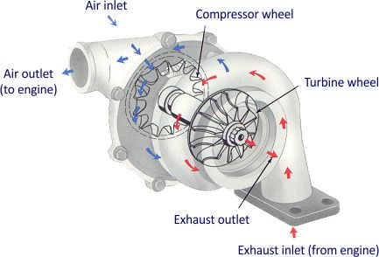

* Uses a turbine to compress incoming air, which is then sent into the engine’s combustion chamber.
* The turbine is powered by exhaust gases, which spin a compressor wheel.
* Can produce more power than a naturally aspirated engine of the same size.
* More efficient than supercharging as it uses energy that would otherwise be wasted to compress the air.
* One of the main drawbacks is turbo lag, which is the delay between pressing the accelerator and the turbocharger producing boost.
* They more complex and require more maintenance than naturally aspirated engines.

1. Supercharged Engine:

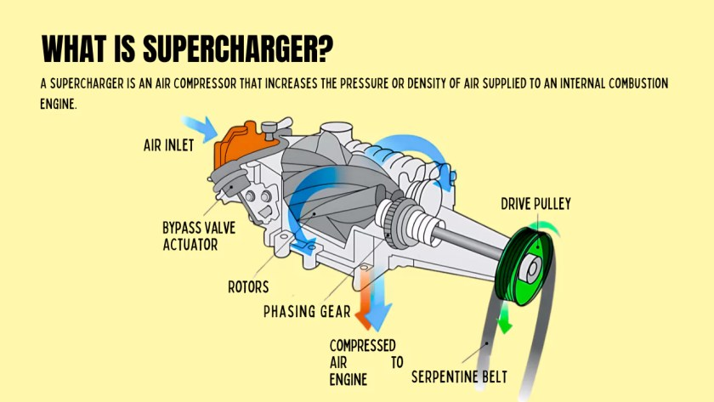

* Uses a belt-driven compressor to compress incoming air
* The compressor is connected to the engine’s crankshaft and spins at the same speed as the engine.
* Can product boost at lower RPMs than a turbocharger, reducing or even eliminating turbo lag.
* Simpler and more reliable than turbocharged engines, as they have fewer moving parts and don’t rely on exhaust gas to function.
* Can be more efficient than turbochargers at lower RPMs, making them ideal for high-performance applications where instant throttle response is important.
* Require energy from the engine to function, which can result in lower overall efficiency and fuel economy.
* Can generate more heat than turbochargers, which can be detrimental to engine performance and reliability.